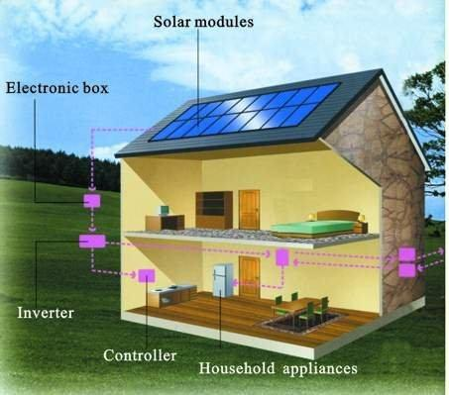

Building Safety

# Training on Solar Permits

August 31st

2:30 p.m. to 3:30 p.m.

600 2ND Street NW

Hearing Room (Basement)

**JOIN US FOR A DISCUSSION REGARDING:** **SOLAR BUILDING PERMITS, SOLAR ELECTRICAL PERMITS**

**AND INSPECTIONS.**

Refreshments will be provided.

